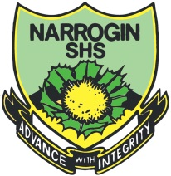


Narrogin Senior High School
English Assessment Cover Sheet – Upper School

STUDENT’S NAME |  | TEACHER’S NAME | Lavan | UNIT 2  FOUNDATION  ENGLISH
DATE DUE: |  | DATE SUBMITTED: |  | YEAR: 11
The words and ideas in this work are all my own. | STUDENT SIGNATURE: | TEACHER SIGNATURE: |  | WEIGHTING:  20%

TASK DETAILS:
TASK 3
Conduct a mock job interview for a job in your chosen career.

ASSESSMENT CONDITIONS:
The period allowed for the completion of this task: 2 weeks

For this task you will need to:
1. Plan your mock job interview by:
a. Watching job interview clips
b. Writing down the questions asked by interviewers
c. Identifying the difference between open and closed questions
d. Writing appropriate open ended questions to use in your job interview
e. Rehearsing responses to interview questions
f. Planning the order of interview questions

2. In your mock job interview:
g. Speak formally
h. Clearly answer the questions
i. Give examples to support your answers to each question

Your progress in this task will be documented in the following ways:
- Completion of class activities
- Planning and rehearsing
- Video of final mock interview

RESOURCES: Ipad & computer

MARKING CRITERIA:

